***3D Printed Part Post Processing***

**Print List**

**1x Top Mount**

**1x Bottom Mount**

**1x Top Slider**

**1x Bottom Slider**

**Top Mount**

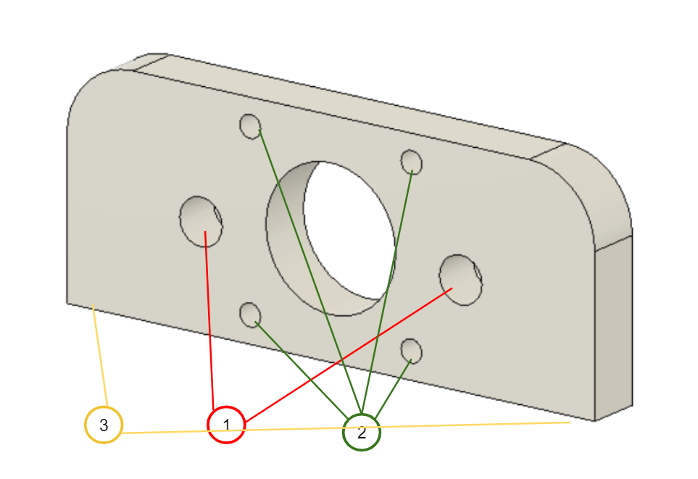

1 - Drill out all 2 holes with 8mm drill bit DO NOT drill all the way through

2 - Drill out all 4 holes with 1/8” drill bit

3 - Drill and tap holes for 1/4” - 20 threads

**Bottom Mount**

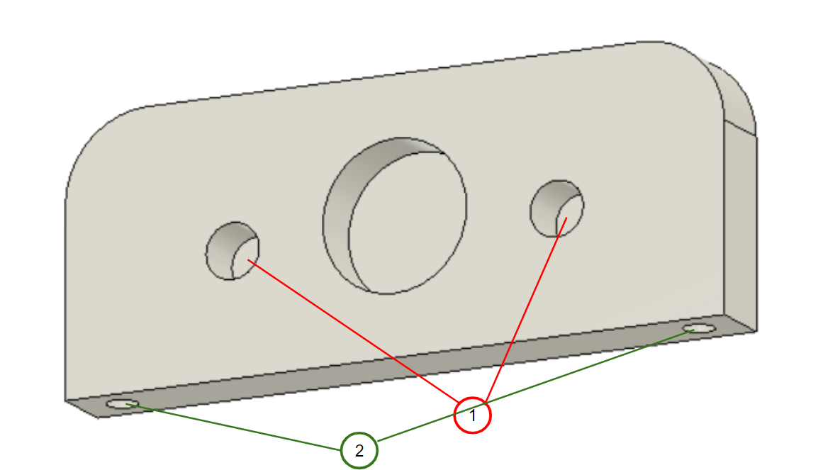

1 - Drill out all 2 holes with 8mm drill bit DO NOT drill all the way through

2 - Drill and tap holes with 1/4”-20 threads

**Top Slider**

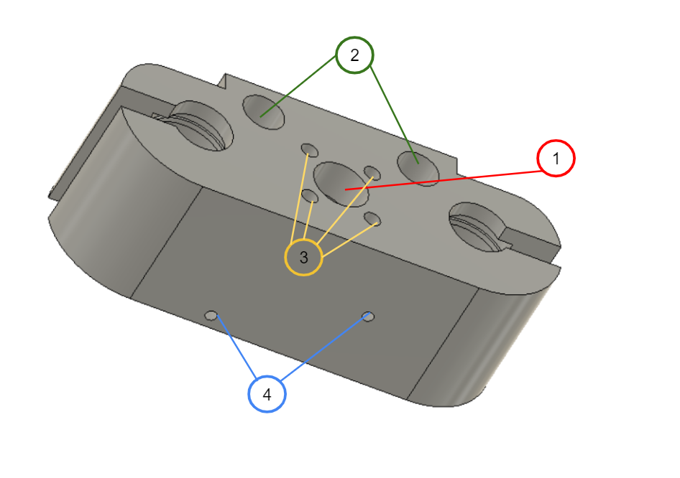

1 - Drill hole out with 10mm drill bit

2 - Drill holes out with 5/16” drill bit

3 - Drill holes out with 1/8” drill bit

4 - Drill and tap holes with M3 Threads

**Bottom Slider**

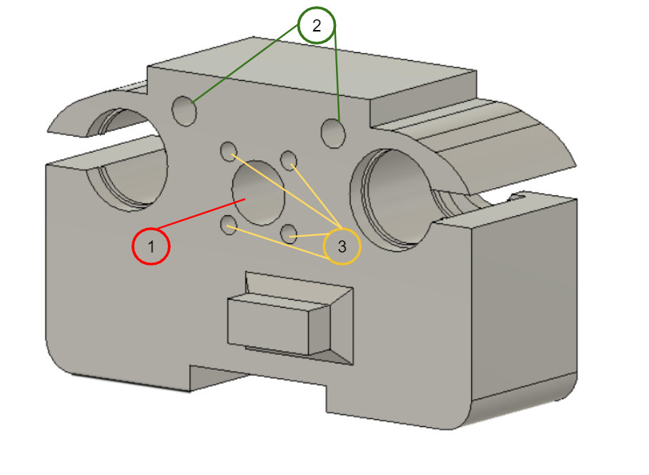

1 - Drill hole out with 10mm drill bit

2 - Drill and tap holes with 1/4”-20 Threads

3 - Drill holes out with 1/8” drill bit